- The Bank of England held Bank Rate at 3.75% at today’s meeting, as expected. There was nothing in the minutes to suggest we should change our call that policy will remain unchanged until next year.
- The committee noted that energy futures prices had fallen since the April meeting and that there was more evidence of sustained disinflation before the conflict began. But policymakers remained cautious on the implications of both developments. We think this is because they’re keen to prevent financial conditions from loosening too much – the majority of the committee appears to think that tighter financial conditions so far have provided breathing space to pursue the ‘wait-and-see’ approach to policy decisions.
The Bank of England's Monetary Policy Committee voted 7-2 to hold Bank Rate at 3.75%. The two dissenters, Huw Pill and Megan Greene, preferred a 25bps hike. Greene had used a recent speech to flag she was likely to switch from no change to voting for a hike, and the narrower margin for no change shouldn’t be seen as a hawkish signal. Most members were content to maintain a ‘wait-and-see’ approach until they could make a more informed judgement on the likely strength of second-round effects via pay growth and margins.
April’s Monetary Policy Report had set out three scenarios with varying assumptions for energy prices and second-round effects. This week’s US-Iran deal has taken energy futures prices below the assumptions used in all of the MPC’s scenarios (Chart 1). Although welcoming this development, the minutes argued that risks to energy prices were skewed to the upside given the unpredictable geopolitical environment and uncertainty about damage to energy supply and wider supply chain disruption.
Chart 1: Oil and gas futures prices are currently below all of the MPC’s April scenarios
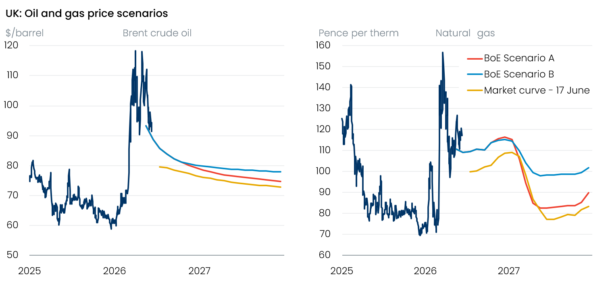
Source: Oxford Economics

Most members also expressed greater reassurance that there had been sustained disinflation before the conflict erupted. However, concerns that short-term inflation expectations remained some way above pre-conflict levels mitigated this positive news.
Most in the no-change camp appear to take the view that the most likely scenario is that a weak labour market and fragile demand will keep a lid on second-round effects via pay growth and margins. And leading indicators on the strength of those second-round effects will remain key to the MPC’s decision making.
Most members argued that financial conditions having tightened significantly since the beginning of the conflict made adopting this ‘wait-and-see’ approach easier. However, market pricing has moved a lot in the opposite direction over the past six weeks. At close yesterday, markets priced 37bps of tightening over the next year, down from 68bps after the April meeting (Chart 2).
Chart 2: Markets have become more dovish in recent weeks as energy futures prices have dropped back
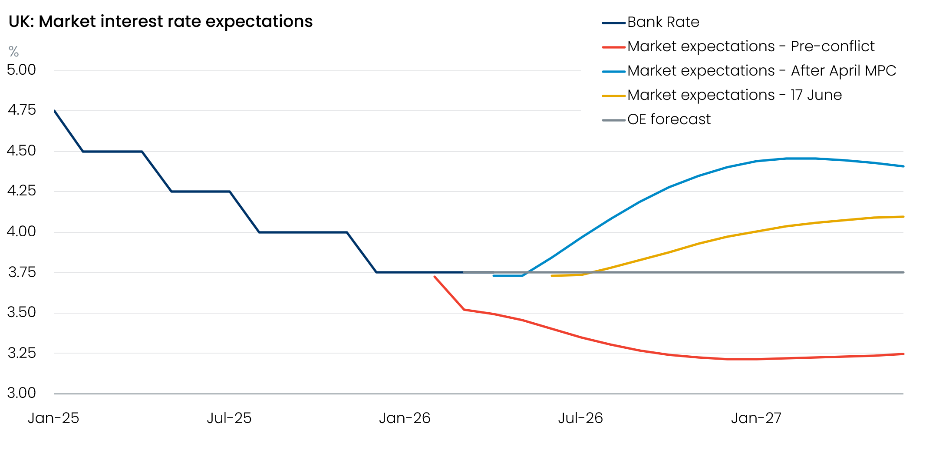
Sources: Oxford Economics, Haver Analytics
We suspect that some of the attempts to play down recent moves in energy prices and to reiterate the willingness of the MPC to act against any emerging second-round effects reflects a desire to prevent financial conditions loosening further in the near term. This, in turn, would make it easier to maintain the wait-and-see approach.
On balance, we can’t see any reason to change our call that Bank Rate will remain at 3.75% for the rest of this year. The majority of the committee appear content to sit back and see how events play out, and we don’t expect to see leading indicators showing evidence of growing second-round effects that might trigger a change of heart.
We continue to expect the next move to be a cut. Our current baseline shows cuts resuming in late 2027, with the committee erring on the side of caution about underlying inflation pressures. But the chances of an earlier move are rising. Cutting sooner would require this week’s US-Iran agreement to lead to a full-blown deal that results in oil and gas prices continuing to fall back. It would also require labour market conditions to remain loose. But given the Middle East situation remains so uncertain, and that it’s advantageous to keep financial conditions relatively tight, we don’t expect there to be much discussion about rate cuts in the MPC’s communications for the time being.

